SEM

## Declaring time series variable

**tsset year, yearly**

## Regress pdi

**regress pdi mcap gdp m3 gdcf fii nds gds**

## gdp m3 nds gds are significant

## Take any one of the significant variable

**regress gds mcap gdp m3 gdcf fii nds**

##Predict hat value

**predict gds_hat,xb**

## regress pdi with the predicted value

**regress pdi mcap gdp m3 gdcf fii nds gds_hat**

## If the predicted value is significant then GDS is ENDOGENOUS.

## Proving endoginity of gds – 2SLS

## Instrumental variable – currently not significant but may be significant in future (nds)

**ivregress 2sls pdi mcap m3 gdp gdcf fii (gds = nds)**

## gds is still significant hence ENDOGENOUS

## Proving endoginity of gds – 3SLS

**reg3 (pdi = mcap gdp m3 gdcf fii gds), exog(mcap gdp m3 fii gdcf) endog(gds) allexog**

## gds is significant hence it is endogenous

VAR (COUNTRY RETURNS)

**tsset date, weekly**

## check for stationarity. T-stats should be lesser than the critical values then the series is stationary

**dfuller brazil, lags(0)**

**dfuller brazil, lags(1)**

**dfuller brazil, lags(2)**

**dfuller brazil, lags(5)**

**dfuller brazil**

**dfuller rbrazil**

**dfuller rbrazil, lags(0)**

**dfuller rchile, lags(0)**

**dfuller rcolombia,lags(0)**

**dfuller rcostarica,lags(0)**

**dfuller rperu,lags(0)**

**dfuller rvenezuela,lags(0)**

### If not stationary then differentiate using D.brazil

**dfuller D.brazil**

## Series stationary at the first difference

## Graphical representation of ACF and PACF

**corrgram brazil**

**corrgram rbrazil**

**pac brazil, lags(10)**

**pac rbrazil,lags(10)**

## Another test for checking stationarity

**pperron brazil, lags(5)**

**pperron rbrazil**

## Basic VAR model

**varbasic rbrazil rchile rcolombia rcostarica rperu rvenezuela, lags(1/2) step(8)**

**o/p:**

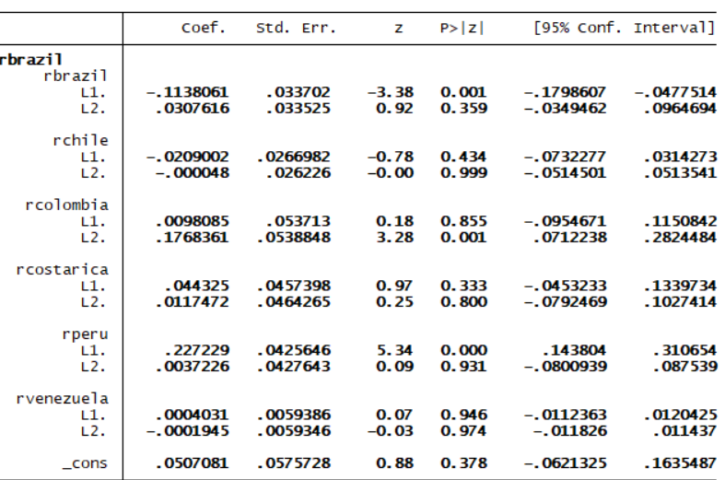

Above is part of o/p which shows how brazil affects other country stock market.

L1🡪 week1

L2 🡪 week 2

(Because of lags 1 and 2)

If prob < 0.05 then rbrazil is significant. Hence we conclude brazil affects itself in Week1 . Brazil affects Columbia in Week 2 and peru in week 1. Do the same analysis for the entire output

**(USED FOR STOCK MARKET ANALYSIS)**

**varsoc rbrazil rchile rcolombia rcostarica rperu rvenezuela, maxlag(7)**

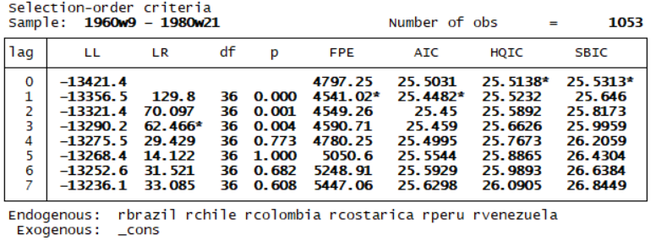

##To select the optimal lag length for the VAR model choose the lag in which me have max no.of *’s with AIC being most important. So in this case lag is **1**

**var rbrazil rchile rcolombia rcostarica rperu rvenezuela, lags(1/1)**

## Same interpretation as above

## Impulse response Graphs

**irf graph irf, irf(varbasic) impulse(rbrazil) response(rcolombia)**

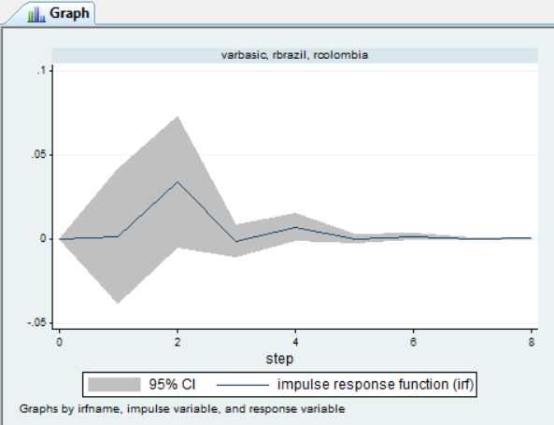

**irf graph irf, irf(varbasic) impulse(rbrazil) response(rchile rcolombia rcostarica)**

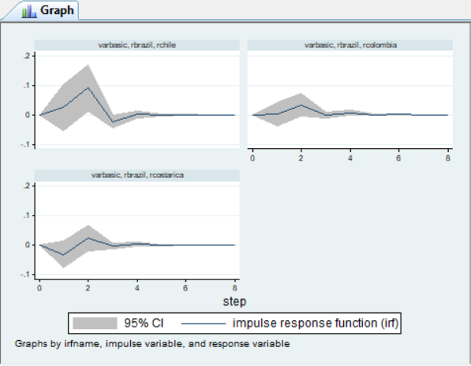

GRANGER CASUALITY

**Vargranger**

## helps us know if one time series helps estimating another time series

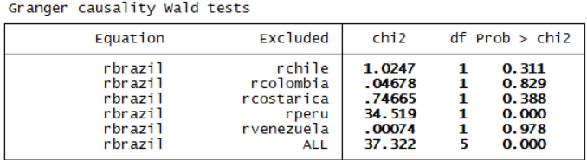

Brazil is causally related to peru and ALL. It means rbrazil and lags of rbrazil are used to predict rperu and ALL

POST ESTIMATION TEST (VAR)

**Varlmar**

## Explain the o/p given below the table

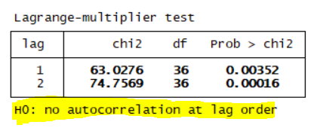

**Varstable**

## Explain the o/p given below the table

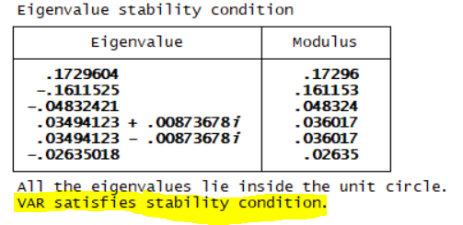

**Varnorm**

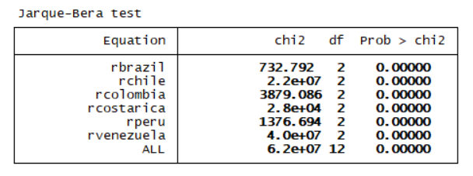

H0 : All variables are normally distributed in VAR

Hence as all prob values are less than 0.05 we reject H0. So the variables are not normally distributed.

VECM

**vecrank rbrazil rchile rcolombia rcostarica rperu rvenezuela, trend(constant)**

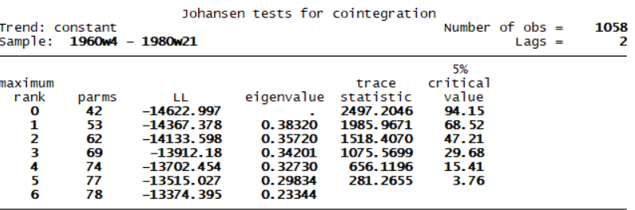

## No *’s so no cointegrating vectors

**vecrank brazil chile colombia costarica peru venezuela, trend(constant)**

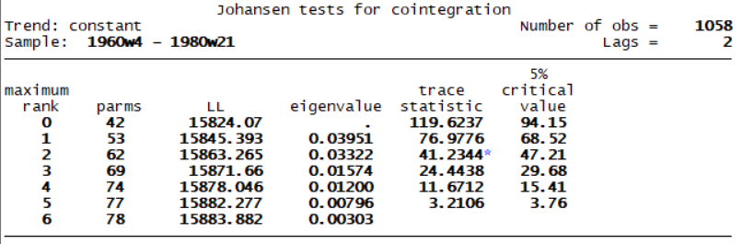

**vecrank brazil chile colombia costarica peru venezuela, trend(constant) lags(4)**

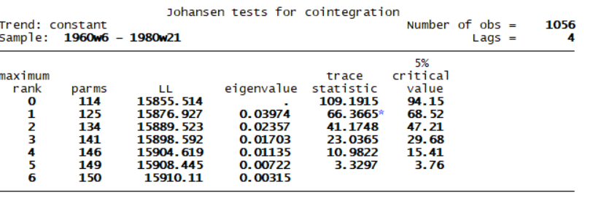

**(SIR’s Notes - Take lag as 4 or 8)**

**vec brazil chile colombia costarica peru venezuela, trend(constant) lags(4)**

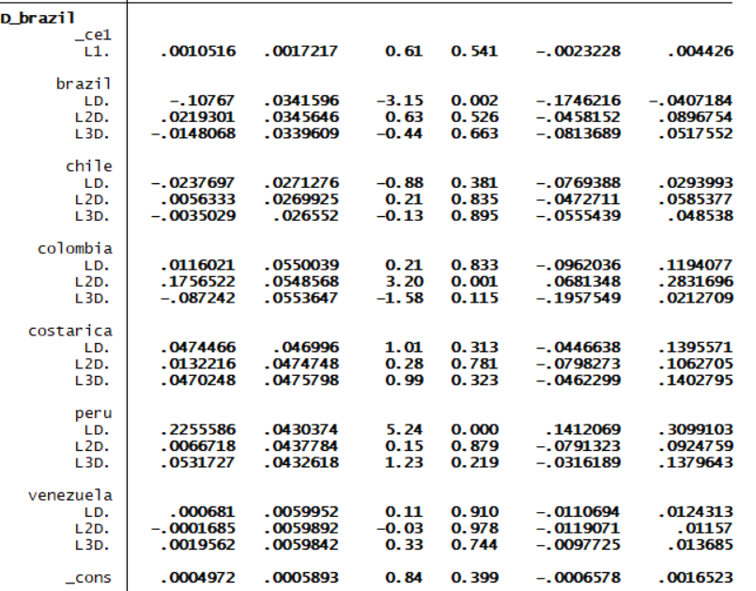

## Brazil will cointegrate with itself at lag 1, with peru at lag 1 and with Columbia at lag 2

(If u put lag as 4 o/p will have -1 lags)

**test(LD.peru LD.brazil)**

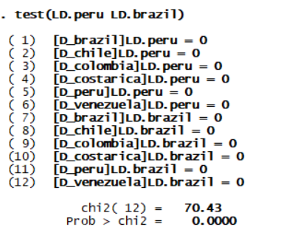

## Another way to test cointegration. If prob <0.05 cointegrated

POST ESTIMATION TEST (VECM)

**veclmar, mlag(5)**

**vecnorm, jbera skewness kurtosis**

PANEL DATA

**xtset c y**

## normal OLS

**regress roa c y ta de lq nexp nimp iipcg intr**

**estimates store OLS**

## xi 🡪 means repeat i.c🡪 creates 100 dummy variables

## Least Square Dummy Variable

**xi: regress roa ta de lq nexp nimp iipcg intr i.c**

**estimates store LSDV**

##areg — Linear regression with a large dummy-variable set

**areg roa ta de lq nexp nimp iipcg intr, absorb(c)**

**estimates store AREG**

## Comparison

**estimates table OLS LSDV AREG,star stats(N r2 r2_a)**

**xtreg roa ta de lq nexp nimp iipcg intr, fe**

**estimates store fe**

**xtreg roa ta de lq nexp nimp iipcg intr, re**

**estimates store re**

#hausman test

**hausman fe re**

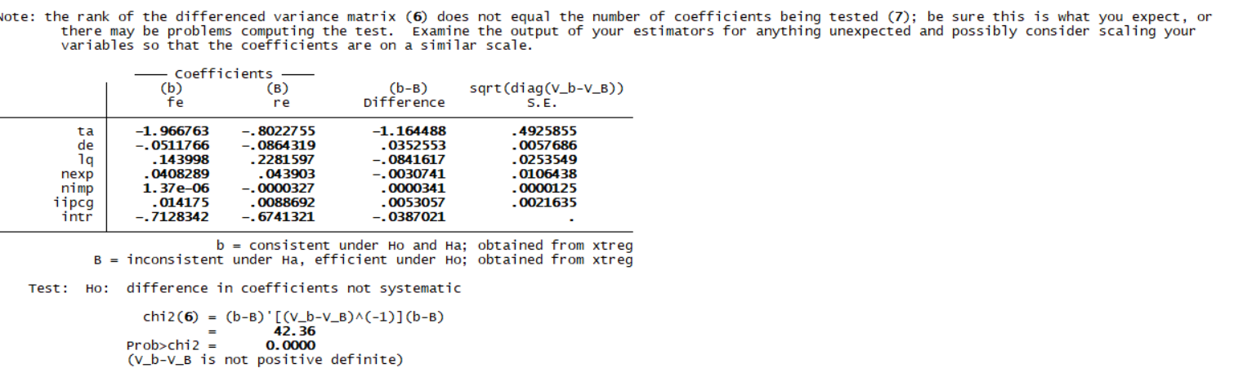

## prob less than 0.05 then use fe model

##post estimation test for re model

**xtreg roa ta de lq nexp nimp iipcg intr, re**

**xttest0**

##prob<0.05 then random effects are present